WEEK – 2

Exercise 1: Setting Up Junit

Nipuna Amanapu

Superset id: 6432842

Scenario:

You need to set up JUnit in your Java project to start writing unit tests.

Steps:

1. Create a new Java project in your IDE (e.g., IntelliJ IDEA, Eclipse).

2. Add JUnit dependency to your project. If you are using Maven, add the following to your pom.xml:

<dependency>

<groupId>junit</groupId>

<artifactId>junit</artifactId>

<version>4.13.2</version>

<scope>test</scope>

</dependency>

3) Create a new test class in your project.

Solution:

1)app.java

package com.example;

public class App

{

public static void main( String[] args )

{

System.out.println( "Hello World!" );

}

}

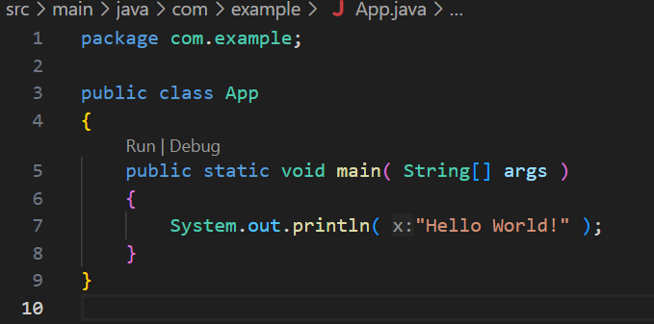

2)app.test.java

package com.example;

import org.junit.jupiter.api.Test;

import static org.junit.jupiter.api.Assertions.assertTrue;

public class AppTest {

    @Test

    public void sampleTest() {

        assertTrue(5 > 1, "5 is greater than 1");

    }

}

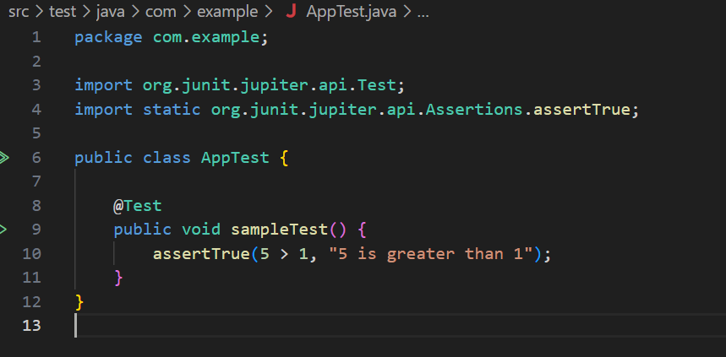

3)pon.xml:

<?xml version="1.0" encoding="UTF-8"?>

<project xmlns="http://maven.apache.org/POM/4.0.0"

         xmlns:xsi="http://www.w3.org/2001/XMLSchema-instance"

         xsi:schemaLocation="http://maven.apache.org/POM/4.0.0 http://maven.apache.org/xsd/maven-4.0.0.xsd">

  <modelVersion>4.0.0</modelVersion>

  <groupId>com.example</groupId>

  <artifactId>junit-setup-example</artifactId>

  <version>1.0-SNAPSHOT</version>

  <name>junit-setup-example</name>

  <url>http://www.example.com</url>

  <properties>

    <project.build.sourceEncoding>UTF-8</project.build.sourceEncoding>

    <maven.compiler.source>17</maven.compiler.source>

    <maven.compiler.target>17</maven.compiler.target>

  </properties>

  <dependencies>

    <dependency>

      <groupId>org.junit.jupiter</groupId>

      <artifactId>junit-jupiter</artifactId>

      <version>5.10.2</version>

      <scope>test</scope>

    </dependency>

  </dependencies>

  <build>

    <plugins>

      <plugin>

        <groupId>org.apache.maven.plugins</groupId>

        <artifactId>maven-surefire-plugin</artifactId>

        <version>3.0.0-M7</version>

      </plugin>

    </plugins>

  </build>

</project>

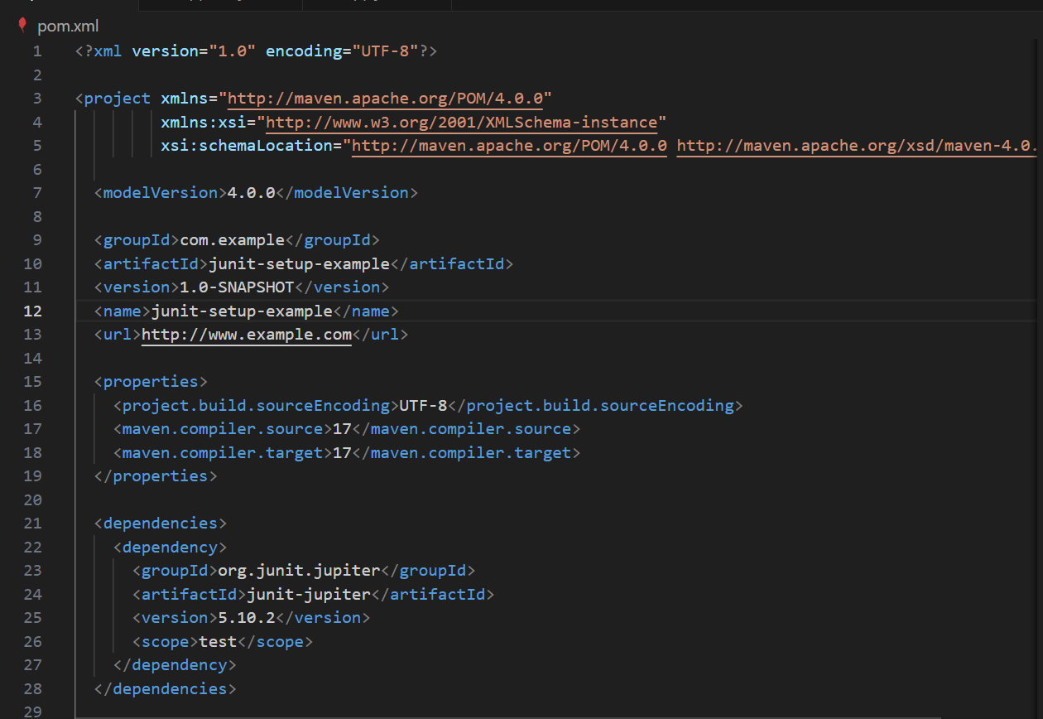

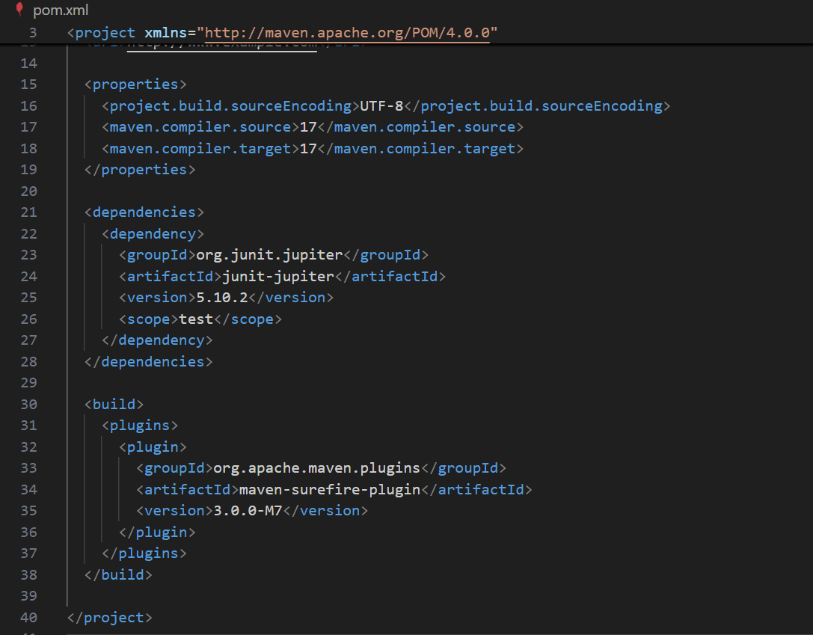

Output:

